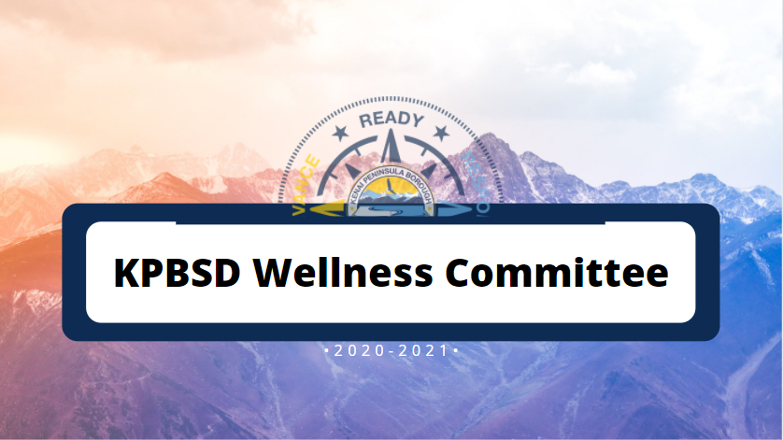
Members Present:
Mike Illg - School Board
Melissa Linton, District Office Administrator
Mark Fraad - PE Teacher, Seward Elementary
Lisa Julissen - PE Teacher, Soldotna Elementary
Diane Buchanan - District Nutrition
Iris Wertz - District Charge Nurse
William Withrow - Principal, Redoubt Elementary
Selma Casagranda - Student Representative, Seward High School
Amorette Payment - Community Member, Parent
Tela O’Donnell - Community Member, Parent
Member(s) Absent: Stacy Cockroft - District Office

October 29, 2020
Virtual Meeting 2:00-3:00 pm
ZOOM LINK
Present: GOOGLE FORM

Agenda
Welcome and Introductions
Review of our Committee’s Charge
Updates from Nutrition (DB)
Survey revision
Next steps and closing

10/29/20 Meeting Notes:

The Wellness Committee took time to introduce themselves and shared one thing they are doing to take care of ourselves during the pandemic.
The committee reviewed the committee’s charge and changes made to Board Policy 5040 in January 2019. The revisions updated language to meet the requirements of Federal breakfast and lunch guidelines. Language in that policy revision states that physical activity should not be used as a punishment, but rather an effective strategy for students to re-engage in their learning and self-regulate their behaviors.

Next, the committee discussed the purpose of the Wellness survey and how Covid might impact the results of such a survey. It was concluded that other types of data should be considered to create the report for the BOE. For example, the nutrition program has data already available that we do not currently utilize. Ms. Linton will develop a list of possible data points for the committee to consider.

The Committee then discussed how we could take a more active role supporting programs for students and families that support wellness. One idea was to create PSA so that more students take advantage of free meals that are being offered during the 2020-2021 school year. Our student representative will also seek input from KPBSD student council.

Our next meeting will be held in January, 2021. Date and time TBD

